THAPAR UNIVERSITY STUDENT SATELLITE INITIATIVE

REPORT ON

ANALOG TO DIGITAL CONVERTORS

SUBMITTED BY:
GURSIMRAN SINGH KESHAV SODHI

ABOUT AVR ADC

CONNECTED TO PORT A (PA0-PA7) 33-44
For instance, it can be used to log the output of a sensor (temperature, pressure, etc) at regular intervals(SAMPLING), or to take some action in function of the measured variable value. There are several types of ADCs. The one used by AVR is of the "succesive approximation ADC" kind. The following is a simplified scheme of the ADC.
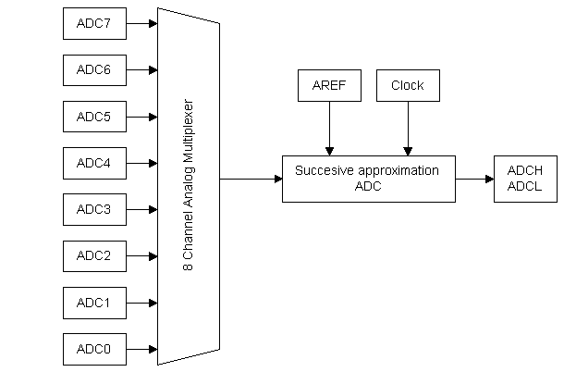

At the input of the ADC itself is an analog multiplexer, which is used to select between eight analog inputs. That means that you can convert up to eight signals (not at the same time of course). At the end of the conversion, the corresponding value is transferred to the registers ADCH and ADCL. As the AVR's registers are 8-bit wide, the 10-bit value can only be held in two registers.

ABOUT THE PROJECT
This ADC takes data from ADC0 pin(PA0,40) and converts the IR sensor’s analog data to 10-bit digital on its own, in free conversing mode, which we use in our program in a loop(POLLING) but for the requirement of the team we have converted the 10-bit data to 6 bit data by using the most significant bits and left adjusting the result in ADCH data register.
The output of this 6-bit data is shown in the PORT-C which is connected to 6 LEDs to verify the result in embedded systems. The first two bits (0 n 1) are controlled by the external interrupt 0 of the ADC, pin (PD2 , 16) of the PDIP.
Interrupts, as the name suggests, interrupt the normal program flow. When an interrupt occurs, the ALU calls the corresponding interrupt vector and executes the code at that address. As the interrupt vectors each are only one word long (classics AVR, two words for some megas), you'd usually put a jump instruction there which goes to an Interrupt Service Routine.
The choice of ADC0 is immaterial any channel of the multiplexer can be used with no major change in coding. Only the corresponding change has to made in ADMUX register of the ADC.
Different interrupts vectors that could be used for the achievement of the goal
VECTOR NO | PROGRAM ADDRESS | SOURCE | INTERRUPT DEFINITION
2 | $002 | INT0 | External Interrupt Request 0
3 | $004 | INT1 | External Interrupt Request 1
19 | $024 | INT2 | External Interrupt Request 2
15 | $01C | ADC | ADC Conversion Complete

We have chosen INT0 external interrupt in our program and in our report. Other possibilities can be set as a task for further study in this topic. This program takes data from the sensor and changes it into 6 bit data.

PROJECT OVERVIEW

SENSOR1
SENSOR2

For 6 bit data(to be sent to adc) For interrupt
MICROCONTROLLER

PORTC LEDs

CIRCUIT DIAGRAM for an IR Sensor
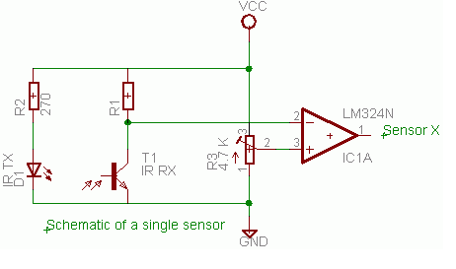
#include<avr/io.h>
#include<avr/interrupt.h>
#include<util/delay.h>
#include<compat/deprecated.h>

ISR(INT0_vect ) //This ISR called when for external interrupt request0 called in IVT.
{
sbi(PORTC,PIN1);
sbi(PORTC,PIN0);

_delay_ms(100);

cbi(PORTC,PIN1);
cbi(PORTC,PIN0);
}

void main(void)
{
char i; //int could also be used but char takes one byte data
//DATA DIRECTION REGISTER FOR PORT C.
DDRC=0xFF; //PortC is output port(ALL BITS SET IN DDR)

//GENERAL INTERRUPT CONTROL REGISTER.
GICR=0X01000000; //Internal interrupt 0 request enable

//MCU CONTROL REGISTER
MCUCR=0X01; //Any logical cange in value at int0 generates an interrupt

sei(); //Enable all global interrupts.SETS GLOBAL INTERRUPT ENABLE BIT IN SREG

//ADC MULTIPLEXER SELECT
ADMUX=0b00100000;
/*Setting result to left adjust
Reference selected to AREF that we provide 4V
Selecting Pin0 as input for sensor1 using mux pins*/

//SPECIAL FUNCTION IO REGISTER
SFIOR=0x00; //Setting auto trigger source to free running mode

//ADC CONTROL AND STATUS REGISTER
ADCSRA=0b11100101;
/*ADC enabled
ADC conversion started
ADTS enabled*/

while(1)
{
i=ADCH; //ADCH stores value of converted data

i=i>>2; //DUMP THE LAST TWO VALUES OF ADC
i=i<<2; //LEFT ADJUST THE VALUES

PORTC=i;
//whatever data we get is displayed in the six led. Last 2(0,1) will be always off.
}
}

PROGRAM IN AVR STUDIO
DETAILED DESCRIPTION OF REGISTERS INVOLVED

Code
DDRC=0xFF; //PortC is output port(ALL BITS SET IN DDR)

Code
GICR=0X01000000; //Internal interrupt 0 request enable

Code
MCUCR=0X01; //Any logical cange in value at int0 generates an interrupt
Code
ADMUX=0b00100000;

ADMUX
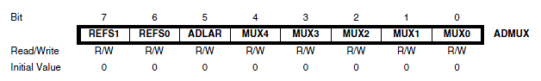

Bit 7:6 – REFS1:0: Reference Selection Bits
These bits select the voltage reference for the ADC. If these bits are
changed during a conversion, the change will not go in effect until this conversion is complete
(ADIF in ADCSRA is set). The internal voltage reference options may not be used if an external
reference voltage is being applied to the AREF pin.
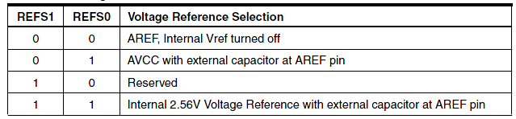

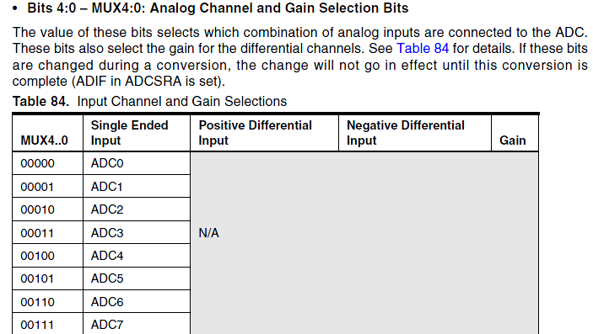

Code
SFIOR=0x00; //Setting auto trigger source to free running mode
SFIOR
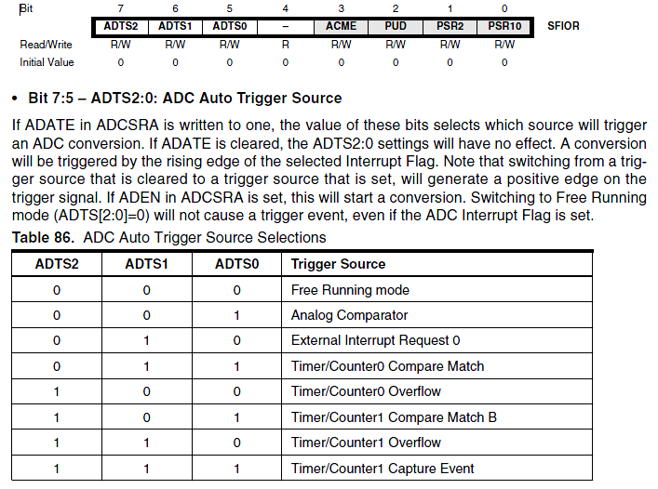

Code
ADCSRA=0b11100101;
ADCSRA
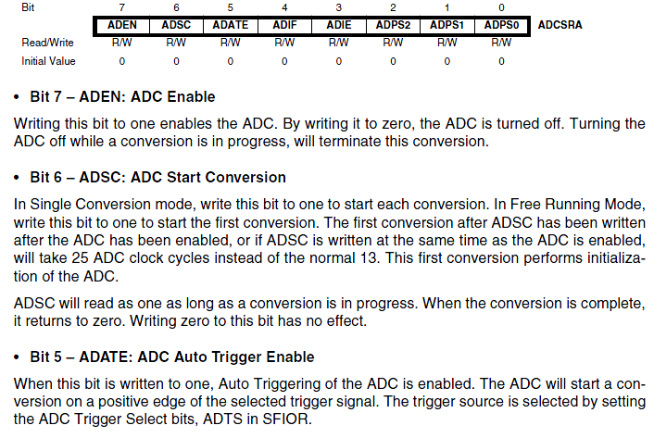
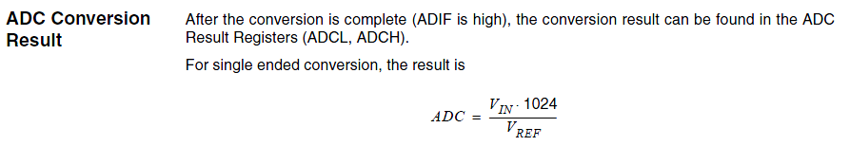

ADCH and ADCL data registers
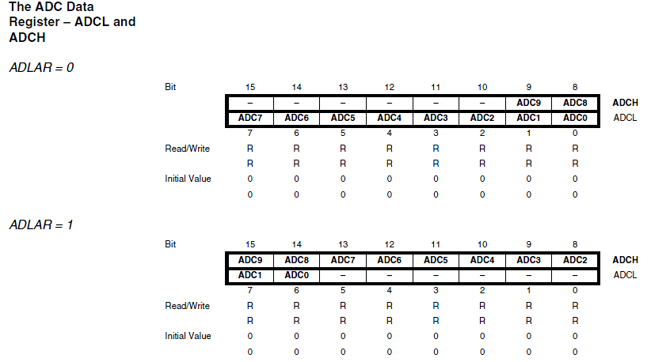

Code
i=i>>2; //DUMP THE LAST TWO VALUES OF ADC
i=i<<2; //LEFT ADJUST THE VALUES

eg
if char i is 11111111
i>>2 is 00111111
i<<2 is 11111100

We therefore get 8 bit data by reading ADCH and then we convert it into 6 bit.
And the output is displayed to last 6 LED’s (PIN2-PIN7) of PORTC.

Program part for sensor 2
This program is used to interrupt the normal running of the program and is used to glow the last 2 LED’s.

OUTPUT EXPLAINED
The reference voltage is the maximum value that the ADC can convert. Our example 8-bit ADC can convert values from 0V to the reference voltage.
In our project we have chosen reference voltage as 5V. This is an assumption so the IR sensor must give voltage from 0-5V as its output for our requirement . This voltage range is divided into 1024 (2 pow 10) values, or steps. The size of the step is given by:
V_{ref}/1024
Where V_{ref} is the reference voltage. The step size of the converter defines the converter's resolution. For a 5V reference, the step size is:
5V/1024 = 0.00488V or 4.88mV (our ADC)
But for the requirement of the team we have truncated 10-bit data to 6-bit data so the max resolution or max change in voltage produced by sensor to make a change in LEDs connected to PORT-C is
5V/1024 = 0.078125V or 78mV (our team requirement)
VOLTAGE RANGE | DECIMAL EQUIVALENT | LED 7  PC7,29 PIN | LED6  PC6,28 PIN | LED5 | LED4 | LED3 | LED2
0-0.078 | 0 | 0 | 0 | 0 | 0 | 0 | 0
0.078-0.156 | 1 | 0 | 0 | 0 | 0 | 0 | 1
0.156-0.234 | 2 | 0 | 0 | 0 | 0 | 1 | 0
0.234-0.312 | 3 | 0 | 0 | 0 | 0 | 1 | 1
0.312-0.39 | 4 | 0 | 0 | 0 | 1 | 0 | 0
0.39-0.468 | 5 | 0 | 0 | 0 | 1 | 0 | 1
0.468-0.546 | 6 | 0 | 0 | 0 | 1 | 1 | 0
So on 64 items…. | 7,8…63
TRUNCATION EXPLAINED
 |  | 2.5v | 1.25v | 625 | 312.5 | 156 | 78.12 | 39 | 19.5 | 9.76 | 4.88mv
 | 1024 | 512 | 256 | 128 | 64 | 32 | 16 | 8 | 4 | 2 | 1
VOL | DECIMAL | BIT9 | BIT8 | BIT7 | BIT6 | BIT5 | BIT4 | BIT3 | BIT2 | BIT1 | BIT0
 | 0 | 0 | 0 | 0 | 0 | 0 | 0 | 0 | 0 | 0 | 0
 | 1 | 0 | 0 | 0 | 0 | 0 | 0 | 0 | 0 | 0 | 1
 | 2 | 0 | 0 | 0 | 0 | 0 | 0 | 0 | 0 | 1 | 0
 | 3 | 0 | 0 | 0 | 0 | 0 | 0 | 0 | 0 | 1 | 1
 | 4 | 0 | 0 | 0 | 0 | 0 | 0 | 0 | 1 | 0 | 0
 | 5 | 0 | 0 | 0 | 0 | 0 | 0 | 0 | 1 | 0 | 1
 | 6 | 0 | 0 | 0 | 0 | 0 | 0 | 0 | 1 | 1 | 0
 | 7 | 0 | 0 | 0 | 0 | 0 | 0 | 0 | 1 | 1 | 1
 | 1023 | 1 | 1 | 1 | 1 | 1 | 1 | 1 | 1 | 1 | 1
Now we have truncated our result form 10-bit to 8-bit for simplicity. We observe that there is no change in the bit3 from decimal 0-3. So we consider this range as one and so neglect the last two bits and count this decimal one in 8 bit system and same result is produced for 0 to 19.5mv ie decimal 0 and again from 4 to 7 bit3 is unchanged with bit0 and bit1 changing values so neglect them and count result from 4-7 as one ie equivalent to decimal 2 in our new truncated system.
So our new truncated system counts only change of 19.5mv so treats 0 and 4.88mv as same giving the same bit word of 0b00000000(truncated result of actual) while the original 10-bit system distinguishes between 0 and 4.88 mv.
EXAMPLE WITH FUTHER EXPLANATION OF HASH FUNCTION(say) AS ABOVE
Take an example of 8-bit converter for simplicity represents the analog input as a digital word. The most significant bit of this word indicates whether the input voltage is greater than half the reference (2.5V, with a 5V reference). Each succeeding bit represents half the range of the previous bit.
Table 1 Example conversion, on an 8-bit ADC ,say
Bit: | Bit 7 | Bit 6 | Bit 5 | Bit 4 | Bit 3 | Bit 2 | Bit 1 | Bit 0
Volts: | 2.5 | 1.25 | 0.625 | 0.3125 | 0.156 | 0.078 | 0.039 | 0.0195
Output Value: | 0 | 0 | 1 | 0 | 1 | 1 | 0 | 0
Table 1 illustrates this point. Adding the voltages corresponding to each set bit in 0010 1100, we get:
.625 + .156 + .078 = .859 volts
The resolution of an ADC is determined by the reference input and by the word width. The resolution defines the smallest voltage change that can be measured by the ADC. As mentioned earlier, the resolution is the same as the smallest step size, and can be calculated by dividing the reference voltage by the number of possible conversion values.
For the example we've been using so far, the resolution is 19.5mV in 8 bit example. This means that any input voltage below 19.5mV will result in an output of 0. Input voltages between 19.5mV and 39mV will result in an output of 1. Between 39mV and 58.6mV, the output will be 2.
Resolution can be improved by reducing the reference input. Changing that from 5V to 2.5V gives a resolution of 2.5/256, or 9.7mV. However, the maximum voltage that can be measured is now 2.5V instead of 5V.
The only way to increase resolution without reducing the range is to use an ADC with more bits. A 10-bit ADC has 2¹⁰, or 1,024 possible output codes. So the resolution is 5V/1,024, or 4.88mV; a 12-bit ADC has a 1.22mV resolution for this same reference.

Future goals/tasks regarding ADC
- Other possibilities of design with different type of interrupts could be implemented to get more comfortable with programming.
- ADC could be further studied in Assembly language programming which is crucial in limited memory environment as TUSSAT and providing fast real-time environment.
- Making our system as real time by knowing precisely the no of clock cycles required for each command and ADC conversions beforehand by changing the frequency acc to us by using the prescaler of ADC.
- Implementing both the free running mode and single conversion mode
- Understanding of noise and other material left with the ADC.

POSSIBLE TESTING THE PROGRAM BEFORE USING IR SENSORS

This example uses the simplest variable voltage source we could think of a potentiometer. This is a 10k potentiometer on a breadboard.
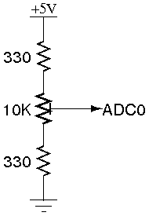
The two outside terminals were attached to 5 volts and ground, with the center terminal attached to the first ADC channel. The two 330 ohm resistors protect the microcontroller pin from being shorted to ground or to 5 volts at the edges of the potentiometer's travel.
With this setup, turning the potentiometer will give you a range of .15 volts to 4.85 volts between ground and ADC0. In order to read the voltage of this circuit, its ground and the ground of the microcontroller need to be connected.
As we donn’t know the voltage output of the IR sensors with the light it receives like it might be linear or non linear. So like this we could never actually test the program. So we must use a potentiometer to test the LEDs glowing according to the analog voltage given to the ADC0 (0-5v).

TERMINOLOGY

RESOLUTION OF ADC
The resolution of the converter indicates the number of discrete values it can produce over the range of analog values. The values are usually stored electronically in binary form, so the resolution is usually expressed in bits. In consequence, the number of discrete values available, or "levels", is usually a power of two. For example, an ADC with a resolution of 8 bits can encode an analog input to one in 256 different levels, since 2⁸ = 256. The values can represent the ranges from 0 to 255 (i.e. unsigned integer) or from -128 to 127 (i.e. signed integer), depending on the application.
Resolution can also be defined electrically, and expressed in volts. The voltage resolution of an ADC is equal to its overall voltage measurement range divided by the number of discrete intervals as in the formula:
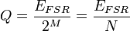
Where:
Q is resolution in volts per step (volts per output code),
E_{FSR} is the full scale voltage range = V_{RefHi} − V_{RefLow},
M is the ADC's resolution in bits.
N is the number of intervals, given by the number of available levels (output codes), which is: N = 2^{M}
Some examples may help:
Example 1
Full scale measurement range = 0 to 10 volts
ADC resolution is 12 bits: 2¹² = 4096 quantization levels (codes)
ADC voltage resolution is: (10V - 0V) / 4096 codes = 10V / 4096 codes 0.00244 V/code 2.44 mV/code
LINEAR ADCs
Non-linear ADCs
If the probability density function of a signal being digitized is uniform, then the signal-to-noise ratio relative to the quantization noise is the best possible. Because this is often not the case, it is usual to pass the signal through its cumulative distribution function (CDF) before the quantization. This is good because the regions that are more important get quantized with a better resolution. In the dequantization process, the inverse CDF is needed.
SAMPLING RATE – no of samples taken in one sec.
POLLING
Polling is what you have to do if your microcontroller does not have interrupts or if what you want to do is not time critical. It is a software technique whereby the controller continually asks a peripheral if it needs servicing. The peripheral sets a flag when it has data ready for transferring to the controller, which the controller notices on its next poll. Several peripherals can be polled in succession, with the controller jumping to different software routines, depending on which flags have been set.
INTERRUPT
Rather than have the microcontroller continually polling - that is, asking peripherals (timers / UARTS / A/Ds / external components) whether they have any data available (and finding most of the time they do not), a more efficient method is to have the peripherals tell the controller when they have data ready. The controller can be carrying out its normal function, only responding to peripherals when there is data to respond to. On receipt of an interrupt, the controller suspends its current operation, identifies the interrupting peripheral, then jumps to the appropriate interrupt service routine. The advantage of interrupts, compared with polling, is the speed of response to external events and reduced software overhead (of continually asking peripherals if they have any data ready).

